Project Design Phase-II
Data Flow Diagram & User Stories
Date | 18 June 2026
Team ID | N/A
Project Name | Book-A-Doctor Healthcare Appointment Management System
Maximum Marks | 4 Marks

Data Flow Diagrams:
A Data Flow Diagram (DFD) is a traditional visual representation of the information flows within a system. A neat and clear DFD can depict the right amount of the system requirement graphically. It shows how data enters and leaves the system, what changes the information, and where data is stored.
DFD Level 0: Book-A-Doctor Context Diagram
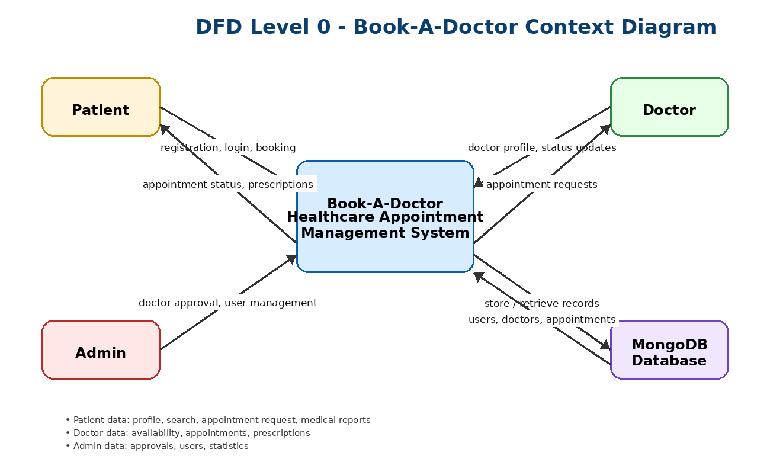

DFD Level 1: Book-A-Doctor Detailed Module Flow
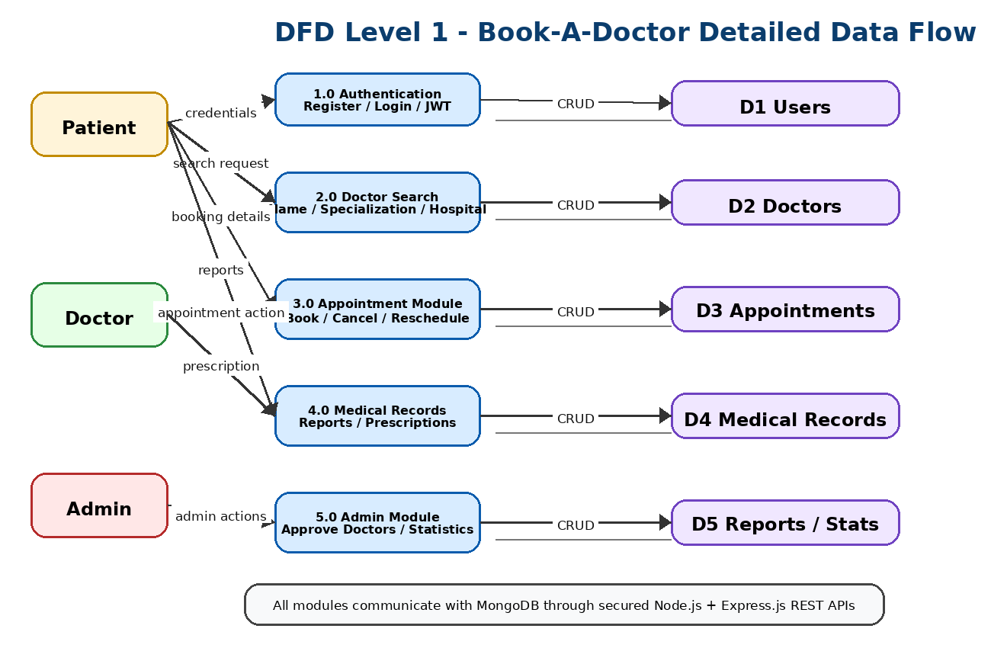

User Stories
Use the below template to list all the user stories for the product.
User Type | Functional Requirement (Epic) | User Story Number | User Story / Task | Acceptance criteria | Priority | Release
Patient | Registration | USN-1 | As a patient, I can register using my name, email, phone and password. | Patient account is created and stored successfully. | High | Sprint-1
Patient | Login | USN-2 | As a patient, I can login securely using email and password. | JWT token is generated and patient dashboard opens. | High | Sprint-1
Patient | Doctor Search | USN-3 | As a patient, I can search doctors by name, specialization and hospital. | Filtered doctor list is displayed correctly. | High | Sprint-1
Patient | Appointment Booking | USN-4 | As a patient, I can book an appointment with an available doctor. | Appointment is saved in database and visible in history. | High | Sprint-2
Patient | Medical Records | USN-5 | As a patient, I can upload and view medical reports. | Uploaded reports are stored and displayed safely. | Medium | Sprint-2
Doctor | Appointment Management | USN-6 | As a doctor, I can approve, reject or reschedule patient appointments. | Appointment status is updated successfully. | High | Sprint-2
Doctor | Prescription Management | USN-7 | As a doctor, I can add prescriptions or notes for patients. | Prescription/notes are saved for the patient appointment. | Medium | Sprint-3
Admin | Doctor Approval | USN-8 | As an admin, I can approve or reject registered doctors. | Approved doctors become visible to patients. | High | Sprint-1
Admin | Dashboard Statistics | USN-9 | As an admin, I can view doctors, patients and appointment statistics. | Dashboard displays correct analytics. | Medium | Sprint-3
References:
https://react.dev/
https://nodejs.org/docs
https://expressjs.com/
https://www.mongodb.com/docs/
https://jwt.io/

